LECTURE 3
PROCESSES

Process Concept
1. Process in Memory
A process is a program that is currently running.
When a program is executed, the operating system loads it into main memory (RAM) and organizes it in a specific way. This organized layout in memory is called process in memory.
Each process gets its own memory space, so one process does not interfere with another.
This memory space is divided into different sections, and each section has a specific purpose.
So, when a process is running, its memory looks like this:
- Some part stores the program code
- Some part stores global data
- Some part stores temporary data
- Some part stores dynamically created data
These parts are known as the four sections of a process.
2. Four Sections of a Process
A process in memory is divided into four main sections:
- Text
- Data
- Heap
- Stack
Each section stores a different type of information and helps the program run smoothly.
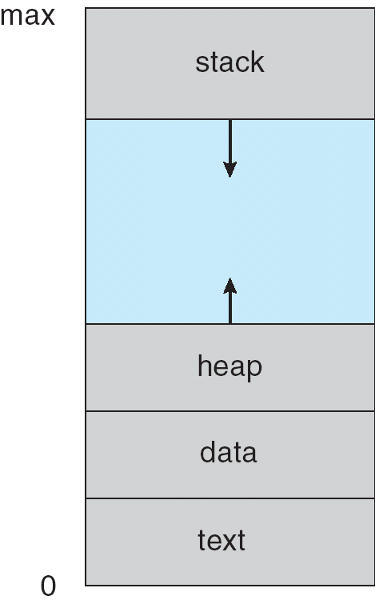
3. Text Section
- The Text section stores the actual program code.
- It contains the instructions that the CPU executes.
- This section is usually read-only, meaning the program cannot change its own instructions.
Example:
If you write a program with a main() function and other functions, all those instructions are stored in the Text section.
Purpose: To store what the program has to do.
4. Data Section
- The Data section stores global and static variables.
- These variables are created before the program starts and remain in memory until the program ends.
Example:
int x = 10; // global variable
static int y = 5;
Both x and y are stored in the Data section.
Purpose:
To store fixed data that is needed throughout the program execution.
5. Heap
- The Heap is used for dynamic memory allocation.
- Memory is allocated during runtime, not at compile time.
- The programmer controls memory allocation and deallocation.
Example:
Using malloc() in C or new in C++ allocates memory in the Heap.
- Heap memory is flexible
- Data can be accessed in any order
- If memory is not freed properly, it can cause memory leaks
Purpose:
To store data whose size is not known in advance.
6. Stack
- The Stack stores temporary data.
- It follows LIFO (Last In, First Out) order.
- It contains:
  - Function parameters
  - Local variables
  - Return addresses
  - Function call information
Example:
When a function is called:
- Its local variables are pushed onto the stack
- When the function ends, its data is popped from the stack
- Stack memory is automatically managed
- It is faster than heap memory
- Stack size is limited
Purpose:
To manage function calls and temporary variables.
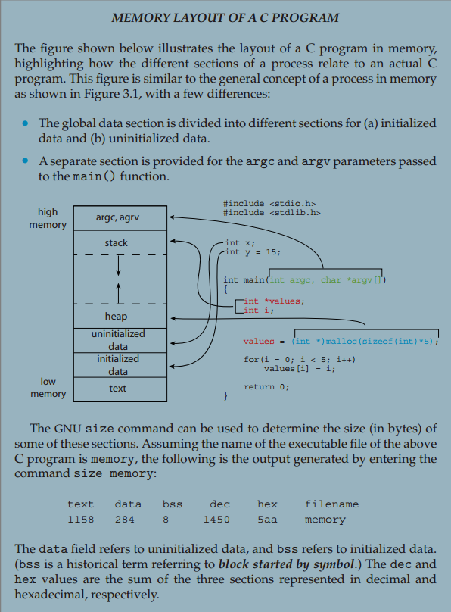
Purpose of Stack and Heap in a Process
Purpose of Stack in a Process
In a process, the stack is used to run functions properly.
It exists to:
- Create a stack frame when a function is called
- Store local variables of that function
- Store function parameters
- Store the return address (where to go back after function ends)
Because of the stack:
- Functions can call other functions
- Functions can return correctly
- Temporary data is handled automatically and fast
In simple words:
The stack helps the process execute functions.
Purpose of Heap in a Process
In a process, the heap is used to store data that needs flexible memory.
It exists to:
- Allocate memory during runtime
- Store large or unknown-size data
- Keep data alive even after a function finishes
Because of the heap:
- Programs are not limited by small stack size
- Data can be shared across functions
- Memory size can be decided while the program is running
In simple words:
The heap helps the process store dynamic and long-living data.
Why stack alone is not enough
- Stack size is limited
- Stack memory is temporary
- Stack memory is automatically destroyed when the function ends
So for things like:
- Large arrays
- User-defined input size
- Objects shared across functions
Stack is not suitable → Heap is the solution
Small example:
void fun() {
int a[1000000]; // ❌ stack overflow (too big)
}
Correct way:
void fun() {
int *a = malloc(1000000 * sizeof(int)); // ✅ heap
}

Process State
A process state tells us what a process is doing at a particular time during its life cycle.
As a process runs, it moves from one state to another.
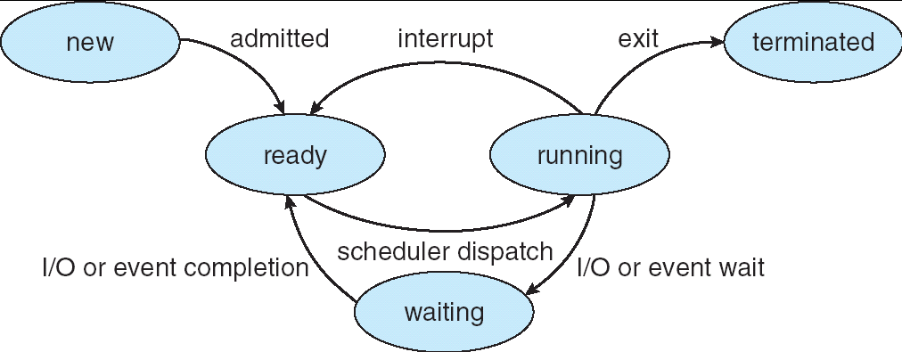
States in the Diagram
1. New → Ready (Admitted)
What happens?
- A program is started (you double-click an app or run a command)
- OS creates a process
- PCB is created
- Memory is allocated
Why it moves to Ready?
- The OS admits the process into main memory
- It is now prepared to run but waiting for CPU
Example:
You open Notepad → process is created → OS loads it into memory → it goes to Ready
2. Ready → Running (Scheduler Dispatch)
What happens?
- CPU becomes free
- Short-term scheduler selects a process from the ready queue
- CPU is assigned to that process
Why this happens?
- OS decides it’s this process’s turn to run
Example:
Notepad is in ready queue → scheduler picks it → Notepad starts executing
3. Running → Ready (Interrupt)
What kind of interrupt?
This is usually a timer interrupt (most important).
Why does this happen?
- Time slice (quantum) expires
- OS uses preemptive scheduling
- CPU must be given to another process
Examples of interrupts:
- Timer interrupt (most common)
- Higher-priority process arrives
- Hardware interrupt
Example:
Your program is running → time slice ends → CPU taken away → process goes back to Ready
4. Running → Waiting (I/O or Event Wait)
What happens?
- Process requests I/O
- CPU cannot execute it further until I/O completes
Why does this happen?
- CPU cannot handle I/O directly
- Process must wait for device or event
Examples:
- Reading from disk
- Waiting for keyboard input
- Network request
- Waiting for a signal
Example:
A program asks to read a file → disk I/O needed → process moves to Waiting
5. Waiting → Ready (I/O or Event Completion)
What happens?
- I/O operation finishes
- Required event occurs
Why does this happen?
- Process now has everything it needs
- Just waiting for CPU again
Example:
File read completes → data arrives → process moves to Ready
6. Running → Terminated (Exit)
What happens?
- Process finishes execution
- Calls exit()
What does OS do?
- Frees memory
- Deletes PCB
- Closes files
Example:
You close Notepad → process finishes → moves to Terminated

Process Control Block (PCB)
What is a PCB?
A Process Control Block (PCB) is a data structure maintained by the operating system that stores all information about a process.
Each process in the operating system is represented by a Process Control Block.
What information does a PCB store?
1. Process State
What it means
It tells the OS what the process is doing right now.
Possible states:
- New
- Ready
- Running
- Waiting
- Terminated
Why it is stored
So the OS knows how to treat the process.
Simple example
- If the process is waiting for input, its state is Waiting
- If it is using CPU, its state is Running
2. Program Counter
What it means
It stores where the process is currently executing in the program.
Think of it as a bookmark in a book.
Why it is stored
So when the process runs again, it can continue from the same place, not start over.
Simple example
- A program stops at line 50
- Program counter = 50
- When it runs again, it starts from line 50
3. CPU Registers
What it means
Registers store small temporary values that the CPU is using while running a process.
Why it is stored
If the process stops, these values must be saved so the process can continue correctly later.
Simple example
- A calculation is half done
- Register stores an intermediate result
- That value is saved in PCB
4. CPU Scheduling Information
What it means
It stores basic execution-related info about the process.
This includes:
- Priority of the process
- Which queue it is waiting in
Why it is stored
So the OS can decide which process should run next.
Simple example
- A high-priority process (like system task) is chosen before others
5. Memory Information
What it means
It stores information about which part of memory is given to the process.
Why it is stored
So:
- The OS knows where the process is stored
- The process does not use memory of other processes
Simple example
- Process A is allowed to use memory from location 1000 to 2000
- This information is stored in PCB
6. Accounting Information
What it means
It stores usage details of the process.
This includes:
- Process ID
- How much CPU time it has used
Why it is stored
So the OS can:
- Monitor process usage
- Control resource use
Simple example
- OS checks how long a process has been running
7. I/O Status Information
What it means
It stores information about input/output used by the process.
This includes:
- Files opened by the process
- Devices being used
Why it is stored
So the OS can manage I/O properly.
Simple example
- A process is reading a file
- File details are stored in PCB
Summary
PCB Stores | Purpose
Process state | What the process is doing
Program counter | Where execution stopped
CPU registers | Temporary CPU data
Scheduling info | When process should run
Memory info | Where process is in memory
Accounting info | How much it has used
I/O info | Files and devices used

CPU Switch from Process to Process
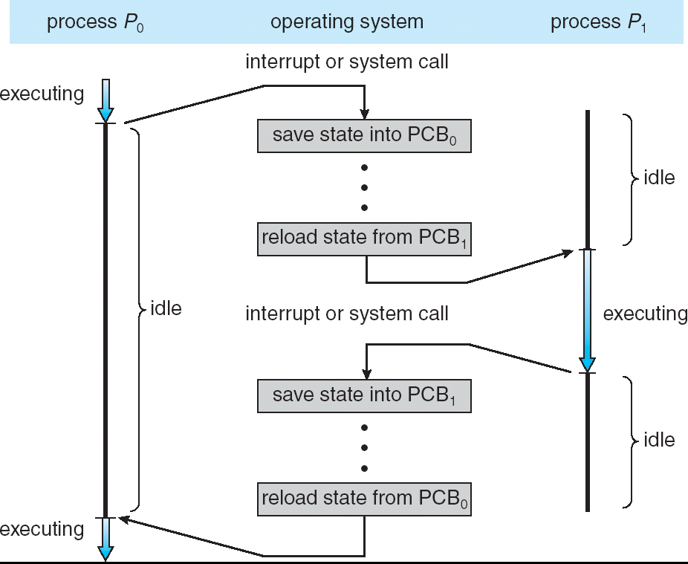
This picture shows how the CPU switches execution between two processes
It explains how PCBs are used during CPU switching
In short: The CPU stops one process, saves its details, then loads another process and starts executing it.
Parts of the diagram
- Left side: Process P₀
- Right side: Process P₁
- Middle: Operating System
- PCB₀: Storage for P₀’s information
- PCB₁: Storage for P₁’s information
Only one process executes at a time.
Step-by-step explanation
Step 1: Process P₀ is executing
- CPU is currently running P₀
- Instructions of P₀ are being executed
- Process P₁ is idle (not using CPU)
In the diagram:
- P₀ → executing
- P₁ → idle
Step 2: Interrupt or system call occurs
An event happens that tells the OS:
“Stop P₀ for now.”
This could be:
- Time slice finished
- P₀ needs I/O
- OS wants to run another process
CPU control moves from P₀ to the OS.
Step 3: OS saves P₀’s state into PCB₀
Now the CPU is running operating system code, not any process.
The OS saves:
- Where P₀ stopped
- Temporary values it was using
- Its current state
This information is stored in PCB₀.
During this time:
- P₀ is NOT executing
- P₁ is also NOT executing
This is the delay you correctly noticed.
Step 4: OS loads P₁’s state from PCB₁
After saving P₀:
- OS reads PCB₁
- Loads P₁’s saved information into the CPU
Now the CPU is prepared to continue P₁.
Step 5: Process P₁ starts executing
- CPU begins executing P₁
- P₀ becomes idle
In the diagram:
- P₁ → executing
- P₀ → idle
To the user, it looks like both programs are running together.
Step 6: Another interrupt or system call occurs
Again, an event tells the OS:
“Stop P₁ now.”
Step 7: OS saves P₁’s state into PCB₁
- OS stores P₁’s current information safely
- P₁ stops executing
Step 8: OS reloads P₀’s state from PCB₀
- OS reads PCB₀
- Restores P₀’s information
- CPU resumes P₀ from the exact point it stopped
Why “idle” is shown in the diagram
A process is shown as idle when:
- It is not using the CPU
- It is waiting for its turn
Idle does not mean finished — just paused.

Process Scheduling
What is Process Scheduling?
Process scheduling is the activity of the operating system that decides:
- Which process should use the CPU
- When it should use the CPU
- For how long
Since there are many processes and only one CPU, the OS must schedule them properly.
In simple words:
Process scheduling decides the order in which processes get the CPU.
What are Scheduling Queues?
Scheduling queues are lists of processes maintained by the operating system.
Processes are placed into different queues based on their current state.
A process moves from one queue to another as it changes state.
Main Scheduling Queues
There are three important queues you need to know:
- Job Queue
- Ready Queue
- Device Queues
1. Job Queue
What is the Job Queue?
The job queue contains all processes in the system.
These are:
- Newly created processes
- Processes that are waiting to be loaded into main memory
They are not yet ready to run.
Why is it needed?
- System may not load all programs into memory at once
- OS selects which jobs to admit into memory
Simple example
You start:
- Browser
- Music player
- PDF reader
All these processes first enter the job queue.
Only some of them will be moved into memory.
2. Ready Queue
What is the Ready Queue?
The ready queue contains processes that:
- Are in main memory
- Are ready to execute
- Are waiting for the CPU
These processes have everything they need except the CPU.
Why is it needed?
- CPU can execute only one process at a time
- Other ready processes must wait in a queu
Simple example
- Browser is loaded into memory
- Music player is loaded into memory
Both are ready, but:
- Only one can run
- The other waits in the ready queue
3. Device Queues
What are Device Queues?
Device queues store processes that are:
- Waiting for an I/O device
- Waiting for an event
Each I/O device has its own queue.
Examples of devices:
- Disk
- Printer
- Keyboard
Why are they needed?
- I/O devices are slow
- Only one process can use a device at a time
Simple example
- Process requests disk read
- Disk is busy
- Process waits in disk device queue
When disk finishes:
- Process moves back to ready queue
How processes move between queues (simple flow)
- Process enters Job Queue
- OS loads it into memory → moves to Ready Queue
- CPU picks it → process starts running
- If it needs I/O → moves to Device Queue
- When I/O completes → back to Ready Queue

Ready Queue and Various I/O Device Queues
Introduction
In a multiprogramming operating system, many processes exist at the same time.
Since the CPU and I/O devices cannot serve all processes at once, the operating system organizes processes into different queues.
These queues help the OS manage CPU time and I/O devices efficiently.
Scheduling Queues
Scheduling queues are lists of processes waiting for some resource.
Each process is represented in a queue by its Process Control Block (PCB).
Ready Queue
Definition
The Ready Queue contains processes that:
- Are loaded in main memory
- Are ready to execute
- Are waiting for the CPU
These processes have everything they need except CPU time.
Structure of Ready Queue
- Maintained as a linked list
- Has:
  - Head → first process to be selected
  - Tail → last process in the queue
- Each entry in the queue is a PCB
Working of Ready Queue
- When a process becomes ready, it is added to the tail of the ready queue.
- The CPU scheduler selects the process from the head of the queue.
- The selected process gets the CPU and starts execution.
Example
- Process P₇ and P₂ are ready to run.
- They wait in the ready queue.
- The CPU picks one process at a time.
I/O Device Queues
Definition
An I/O Device Queue contains processes that are:
- Waiting for a specific I/O device
- Unable to continue execution until the I/O operation completes
Each I/O device has its own separate queue.
Types of I/O Device Queues
Examples include:
- Disk queue
- Keyboard (terminal) queue
- Printer queue
- Magnetic tape queue
Structure of I/O Device Queues
- Each device has:
  - A head and tail
- PCBs of waiting processes are linked together
- Only one process can use a device at a time
Working of I/O Device Queues
- A running process requests an I/O operation.
- The process is moved to the corresponding device queue.
- When the I/O operation completes:
  - The process is removed from the device queue
  - It is moved back to the ready queue
Example
- A process requests disk access.
- Disk is busy.
- Process waits in the disk queue.
- After disk operation completes, the process returns to the ready queue.

Representation of Process Scheduling
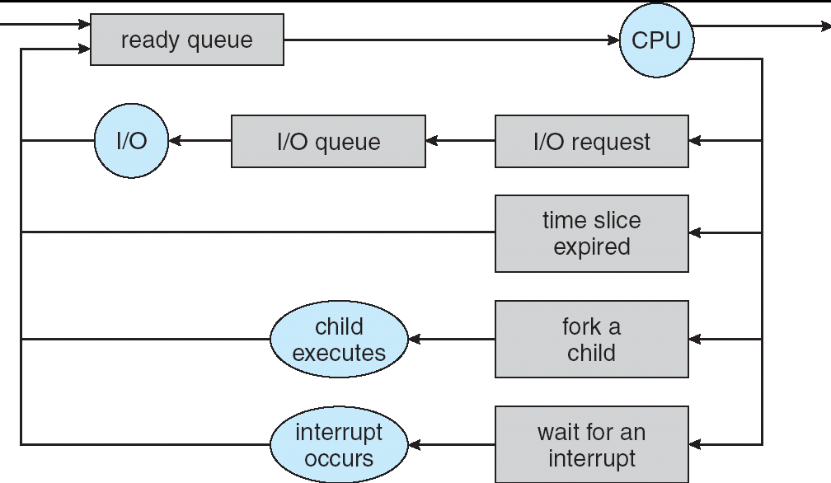
The process scheduling flow begins when a process enters the ready queue. This queue contains all processes that are ready to execute and are waiting for CPU time. The CPU scheduler selects one process from the ready queue and dispatches it to the CPU, where it enters the running state.
While the process is running on the CPU, one possible event is that the process makes an I/O request, such as reading from a disk or waiting for keyboard input. When this request is made, the process cannot continue execution, so the operating system moves it from the CPU to the appropriate I/O queue. At this point, the process is in the waiting (blocked) state, and the CPU is freed to run another process.
After the I/O operation completes, the I/O device sends an I/O completion interrupt to the CPU. This interrupt informs the operating system that the requested I/O operation has finished. As a result of this interrupt, the operating system moves the process from the I/O queue back to the ready queue, where it waits again for CPU allocation.
Another event shown in the diagram is time slice expiration. In a time-sharing system, each running process is given a fixed amount of CPU time called a time slice. When this time slice expires, a timer interrupt occurs. This timer interrupt causes the operating system to stop the currently running process, save its state, and move it back to the ready queue, allowing another process to execute.
The diagram also shows the case where a process forks a child process. When a running process creates a child process, the newly created child is placed into the ready queue. Depending on scheduling decisions, either the parent or the child may execute next. No external interrupt is required here; this happens due to a system call made by the process.
When a process is running on the CPU, it may reach a point where it cannot continue execution because it is waiting for some external event to occur. Instead of wasting CPU time by continuously checking for that event, the process voluntarily blocks itself and enters the waiting state. This situation is described in the diagram as “wait for an interrupt.” At this stage, the process is not using the CPU, and the operating system is free to schedule another process for execution.
The process remains in the waiting state until the required external event occurs. This event may be the completion of an I/O operation, the arrival of input from a keyboard, or any other hardware-related activity. When the event occurs, the corresponding hardware device sends an interrupt signal to the CPU. This interrupt notifies the operating system that the condition the process was waiting for has now been satisfied.
After receiving the interrupt, the operating system wakes up the blocked process and changes its state from waiting to ready. The process is then placed back into the ready queue, where it waits for its turn to be assigned the CPU again. The process does not resume execution immediately; it will run only when the CPU scheduler selects it from the ready queue.
Throughout the entire diagram, interrupts play a critical role. I/O completion interrupts move processes from waiting to ready, while timer interrupts move processes from running to ready. These controlled interruptions allow the operating system to share the CPU fairly among many processes and respond efficiently to external events.

Schedulers
A scheduler is a part of the operating system that decides which process should execute and when.
In a multiprogramming system, many processes exist at the same time, but the CPU can execute only one process at a time.
Schedulers help manage this situation.
Long-Term Scheduler (Job Scheduler)
Definition
The Long-Term Scheduler, also called the Job Scheduler, selects which processes should be brought into the ready queue.
Where it works
- Selects processes from the Job Queue
- Loads them into main memory
- After admission, processes enter the Ready Queue
Main Function
- Controls the degree of multiprogramming
Degree of multiprogramming = number of processes present in main memory at the same time.
Frequency and Speed
- Invoked very infrequently
  - Time scale: seconds or minutes
- Because it runs rarely, it may be slow
CPU-bound and I/O-bound Processes
The long-term scheduler decides which type of processes to admit:
I/O-bound process
- Spends more time doing I/O than computation
- Has many short CPU bursts
CPU-bound process
- Spends more time doing computation
- Has few but long CPU bursts
The scheduler tries to keep a good mix of both to keep the system efficient.
Short-Term Scheduler (CPU Scheduler)
Definition
The Short-Term Scheduler, also called the CPU Scheduler, selects which process should be executed next and allocates the CPU to it.
Where it works
- Selects a process from the Ready Queue
- Assigns the CPU
- Moves the process to the Running state
Main Function
- Decides which ready process gets the CPU next
- Performs CPU scheduling
Frequency and Speed
- Invoked very frequently
  - Time scale: milliseconds
- Because it runs very often, it must be very fast
Why it must be fast
- Scheduling time is overhead
- During scheduling, the system does no useful work
- A slow scheduler wastes CPU time
When is the Short-Term Scheduler invoked?
- When a process moves:
  - Ready → Running
  - Running → Ready (time slice expires)
  - Waiting → Ready (I/O completes)
  - When a process terminates
Long-Term Scheduler vs Short-Term Scheduler
The long-term scheduler is responsible for deciding which processes are allowed to enter the system. It selects processes from the job queue and loads them into main memory, after which they are placed in the ready queue. Its main role is to control the degree of multiprogramming, meaning how many processes are present in memory at the same time. Because this decision does not happen often, the long-term scheduler is invoked very infrequently (after seconds or minutes), so it does not need to be fast. It also decides the mix of CPU-bound and I/O-bound processes to keep the system balanced.
On the other hand, the short-term scheduler is responsible for deciding which process should get the CPU next. It selects a process from the ready queue and allocates the CPU to it, moving the process into the running state. This scheduler is invoked very frequently, usually in milliseconds, such as when a time slice expires or an I/O operation completes. Because it runs so often, it must be very fast, otherwise CPU time would be wasted. Unlike the long-term scheduler, it does not control how many processes enter the system; it only controls CPU execution order.
In simple words, the long-term scheduler decides which processes are allowed into memory, while the short-term scheduler decides which process runs on the CPU at any given moment.
Addition of Medium-Term Scheduling
Why Medium-Term Scheduler is added
In multiprogramming systems:
- Too many processes in main memory can:
  - Slow down the system
  - Increase context switching
  - Reduce CPU efficiency
To control this, the OS introduces the Medium-Term Scheduler.
What is the Medium-Term Scheduler?
The Medium-Term Scheduler is responsible for:
- Temporarily removing processes from main memory
- Bringing them back later when needed
This process is called swapping.
Key Concept: Swapping
- Swap out → Move a process from main memory to secondary storage
- Swap in → Bring a process back from secondary storage to main memory
The medium-term scheduler decides which process to swap out and when.
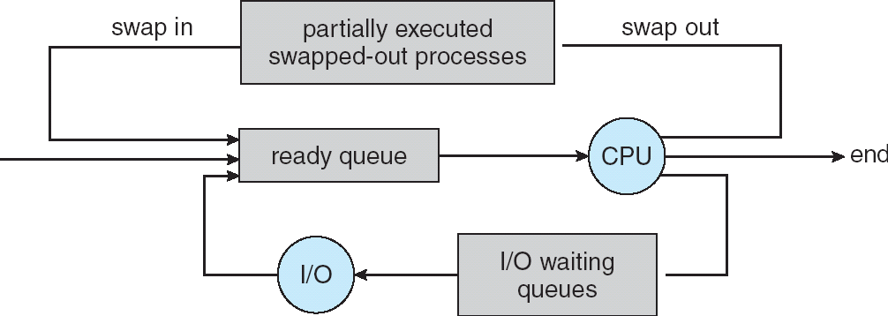

Explanation of the Diagram
1. Ready Queue → CPU
- Processes that are in main memory, or are ready to be executed, are stored in the Ready Queue
- The CPU selects one process and executes it
2. CPU → I/O Waiting Queues
- While executing, a process may request I/O
- The process is then moved to the I/O waiting queue
- CPU is freed for another process
3. Swap Out (Medium-Term Scheduler action)
- Some processes may be:
  - Waiting for I/O
  - Or partially executed but inactive
- The Medium-Term Scheduler:
  - Swaps out these processes from memory
  - Stores them as partially executed, swapped-out processes
This frees main memory and reduces load
4. Partially Executed Swapped-Out Processes
- These processes:
  - Are not terminated
  - Are paused
  - Their state is saved
- They stay in secondary storage until needed again
5. Swap In → Ready Queue
- When memory becomes available:
  - Medium-term scheduler swaps in a process
- The process is:
  - Loaded back into main memory
  - Placed in the Ready Queue
- It can now compete for CPU again
6. Process Continues Execution
- When selected by the short-term scheduler
- The process resumes execution from where it stopped
Role of Medium-Term Scheduler
- Performs swap in and swap out
- Manages partially executed processes
- Reduces degree of multiprogramming temporarily
- Improves overall system performance
CPU Burst Concept
A process does not use the CPU continuously during its entire execution. Instead, execution occurs in periods called CPU bursts. A CPU burst is the time during which a process actively executes instructions on the CPU. After a CPU burst, the process may need to perform an input/output operation, such as reading from a disk or waiting for user input. During this time, the process enters an I/O burst and remains blocked until the I/O operation completes. This cycle of CPU burst followed by I/O burst continues until the process finishes execution.
CPU-Bound Processes
A CPU-bound process is a process that spends most of its execution time performing computations on the CPU. In such processes, CPU bursts are long, and I/O operations are infrequent. This means the process remains on the CPU for extended periods before requesting any I/O. CPU-bound processes mainly depend on CPU speed for their performance and are common in tasks that involve heavy calculations, such as mathematical computations, scientific simulations, image processing, and encryption algorithms.
I/O-Bound Process
An I/O-bound process is a process that spends most of its time waiting for input/output operations rather than performing calculations. It uses the CPU only for a very short time to handle an I/O request, such as processing a keyboard input, reading a file, or sending data to a device. After this brief CPU usage, the process immediately releases the CPU and enters the waiting state until the I/O operation completes.
Because the CPU is used only to start or handle the I/O request, the CPU bursts are short. The waiting time that follows is not counted as CPU time, so it does not make the CPU burst longer. This cycle repeats many times: a short CPU burst to process an input, followed by a waiting period for the next I/O. A good example is typing on a keyboard—each key press causes a short CPU burst, and then the process waits for the next key press. As a result, I/O-bound processes have many short CPU bursts, and their performance mainly depends on the speed of I/O devices rather than the CPU.

Context Switch
Definition of Context Switch
- A context switch occurs when the CPU switches from one process to another.
- The operating system saves the state of the currently running process.
- The saved state is stored in the Process Control Block (PCB).
- The OS then loads the saved state of the next process.
- This allows each process to resume execution from where it stopped.
Context Switch Overhead
- Context switching takes CPU time.
- During a context switch, the CPU does no useful work.
- Saving and restoring process state causes overhead.
- Frequent context switches reduce overall system performance.
- Overhead is higher in time-sharing systems due to frequent switching.
Hardware Dependency
- Context switch time depends on hardware support.
- Systems with Fast memory, Multiple registers, Special hardware instructions can perform context switches faster.
- Poor hardware support increases context switch time and overhead.

Process Creation
Parent and Child Processes
In an operating system, a running process can create another process. The process that creates a new process is called the parent process, and the newly created process is called the child process. After creation, both parent and child exist as separate processes and are managed independently by the operating system. Each process has its own Process Control Block (PCB), which stores its state and execution information.
The child process is usually created to perform a task that the parent process needs. Even though the child is created from the parent, it can run independently and may execute different code depending on the program logic.
Example:
When you run a command in a Linux terminal, the shell is the parent process. It creates a child process to execute the command. After the command finishes, the child process ends, while the shell continues running.
Process Tree
When a parent process creates one or more child processes, and those child processes may further create their own child processes, a hierarchical structure is formed. This structure is called a process tree. In this tree, every process (except the first process) has exactly one parent, and a process may have multiple children.
The process tree helps the operating system keep track of relationships between processes, such as which process created which child and which processes should be terminated together if needed.
Example:
In UNIX-based systems, the init (or systemd) process is the root of the process tree. It creates system services, login shells, and user programs. When you open a terminal and run programs, all of those processes appear as branches under the shell in the process tree.
Resource Sharing Models
When a parent process creates a child process, the operating system must decide how resources will be shared between them.
Resources include open files, memory, data, and devices.
There are three possible resource sharing models:
1. Parent and Child Share All Resources
- Parent and child use the same resources.
- Any change made by one process is visible to the other.
Example:
A parent process opens a file and creates a child. Both parent and child write to the same open file.
This is efficient but can cause problems if not controlled properly.
2. Child Shares a Subset of Parent’s Resources
- Some resources are shared.
- Other resources are kept separate.
- This is the most common model used in operating systems.
Example:
The child process may share:
- Open files
But have its own memory space
This allows cooperation without full dependency.
3. Parent and Child Share No Resources
- Parent and child are completely independent.
- Each process has its own resources.
Example:
Parent and child open separate files and use separate memory.
Changes in one process do not affect the other.
Execution Models (Concurrent / Waiting)
After a child process is created, the parent and child may execute in different ways.
Concurrent Execution
- Parent and child execute at the same time.
- The CPU switches between them using scheduling.
- Both processes make progress independently.
Example:
Consider a web browser as the parent process. When you open a new tab, the browser creates a child process to load the webpage. The parent browser process continues running and remains responsive, allowing you to scroll, open menus, or type in the address bar, while the child process fetches data from the internet and renders the page. The CPU switches between the parent and child processes, so both execute concurrently. The parent does not wait for the child to finish loading the page; both processes make progress at the same time.
Parent Waiting for Child
- Parent process waits until the child finishes execution.
- Parent uses a system call like wait().
- Parent resumes only after the child terminates.
Example:
Consider a command-line shell in a UNIX system as the parent process. When you type a command such as ls or gcc program.c, the shell creates a child process to execute that command. After creating the child, the shell uses a waiting mechanism and pauses its execution. The child process runs, completes the command, and then terminates. Only after the child finishes does the parent shell resume execution and display the command prompt again. This is an example of the waiting execution model, where the parent waits for the child to complete.

Detailed Sequence of Process Creation and Execution in UNIX
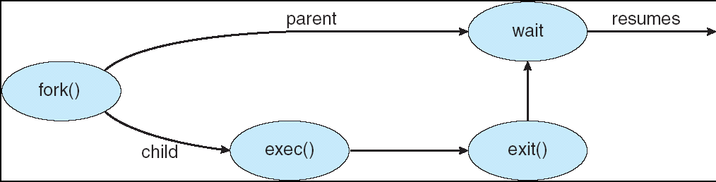
1. Address Space of Child Process (First thing the OS decides)
When a process wants to create another process, the operating system must first decide what memory (address space) the new process will have.
- The address space includes:
  - Program code (text section)
  - Global and static data
  - Stack
  - Heap
When a child process is created:
- The child initially receives a copy of the parent’s address space.
- This means the child has:
  - The same program code
  - The same data
  - The same execution point
- However, this is a logical copy:
  - Parent and child have separate memory
  - Changes in one process do not affect the other
At this point, both processes are identical in terms of memory and code.
2. fork() System Call (How the child is created)
The actual creation of the child process is done using the fork() system call.
What happens when fork() is called:
- The operating system:
  - Creates a new Process Control Block (PCB) for the child
  - Assigns a new Process ID (PID) to the child
  - Copies the parent’s address space into the child
- Execution continues from the same instruction in both processes.
Return values of fork():
- Returns 0 in the child process
- Returns child’s PID in the parent process
This return value allows the program to:
- Identify whether it is running in the parent or the child
- Execute different code in each process
Now there are two separate processes running the same program.
3. exec() System Call (How the child runs a new program)
In most cases, the child process is created to run a different program, not the same one as the parent.
To do this, the child uses the exec() system call.
What exec() does in detail:
- Removes the current program from the child’s memory
- Loads a new executable program into the same process
- Replaces:
  - Code section
  - Data section
  - Stack
  - Heap
- The process ID remains unchanged
- Execution starts from the beginning of the new program
⚠ Important:
- exec() does not create a new process
- It only changes what program the process is running
After exec(), the child process is no longer a copy of the parent.

A tree of processes on a typical Solaris
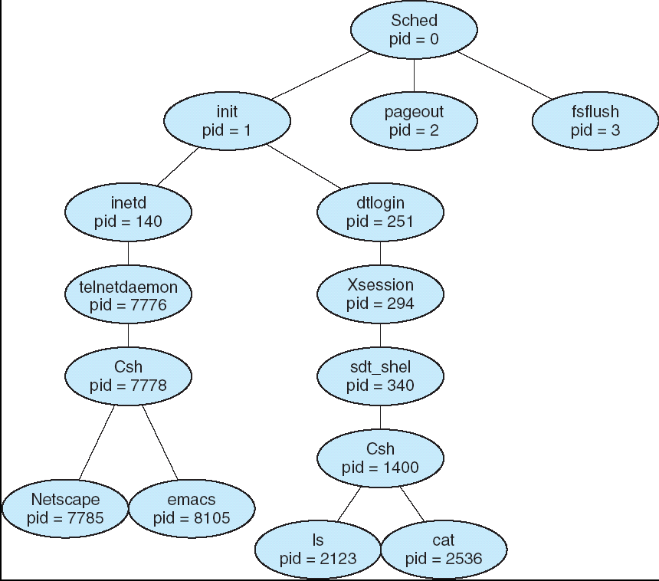
This diagram represents a process tree in a typical Solaris (UNIX-based) operating system and explains how processes are organized and related to one another in a hierarchical structure. At the very top of the tree is the scheduler process (pid = 0), which is created by the kernel when the system starts. This process is responsible for low-level scheduling activities and acts as the root of the entire process tree. From the scheduler, the init process (pid = 1) is created. The init process is extremely important because it is responsible for starting almost all other system processes and services during system initialization.
The init process creates several system daemon processes, such as pageout (pid = 2), which handles memory paging, and fsflush (pid = 3), which manages periodic flushing of file system data to disk. These daemon processes run in the background and provide essential operating system services. In addition to system daemons, init also creates network and login-related processes such as inetd and dtlogin. The dtlogin process manages graphical logins, and once a user successfully logs in, it creates a user session process such as Xsession, which further starts a shell for the user.
The shell process (for example, csh) plays a central role in user interaction. It acts as a parent process for all commands entered by the user. Whenever the user runs a command such as ls, cat, emacs, or netscape, the shell creates a child process to execute that command. Each command runs as a separate process with its own process ID, and once the command finishes execution, the corresponding child process terminates while the shell remains active and waits for the next user command. This continuous creation and termination of child processes under the shell clearly demonstrates the parent–child relationship shown in the process tree.
Overall, the diagram is trying to convey that processes in a UNIX system are not independent; instead, they are organized in a tree structure where every process (except the root) has exactly one parent. It shows how system processes lead to user processes, how shells create child processes to run commands, and how the operating system uses this hierarchical organization to manage process creation, execution, and termination efficiently.

Process Termination
Process termination refers to the end of execution of a process. A process may terminate either normally or abnormally. When a process terminates, the operating system performs cleanup tasks such as releasing resources and updating process information.
Normal Termination (exit)
Normal termination occurs when a process finishes its execution successfully.
- A process calls the exit() system call to terminate.
- This indicates that the process has completed its task.
- The process may return a status value to its parent.
- After calling exit(), the process stops execution permanently.
Example:
A program that prints output and completes its execution normally calls exit() when finished.
Parent Waiting for Child (wait)
When a child process terminates, the parent process may need to know when and how the child finished.
- The parent process uses the wait() system call.
- wait() causes the parent to:
  - Pause execution
  - Wait until the child terminates
- After the child finishes:
  - The parent resumes execution
  - The parent receives the child’s exit status
Example:
A shell waits for a command (child process) to finish before displaying the prompt again.
Resource Deallocation
When a process terminates, the operating system must free all resources used by the process.
These include:
- Memory space (code, data, stack, heap)
- Open files
- I/O devices
- CPU scheduling information
- Process Control Block (PCB)
This cleanup is essential to:
- Prevent resource leakage
- Allow reuse of system resources
Abnormal Termination (abort)
Abnormal termination occurs when a process ends unexpectedly or is forced to terminate.
- A process may be aborted due to:
  - Illegal memory access
  - Division by zero
  - Hardware failure
  - Explicit termination by another process or OS
- The operating system may also terminate a process to protect system stability.
Example:
If a program tries to access unauthorized memory, the OS aborts it.
Cascading Termination
Cascading termination occurs when termination of a parent process causes termination of its child processes.
- Some operating systems do not allow orphaned child processes.
- When a parent terminates:
  - All its children are also terminated automatically.
- This is called cascading termination.
Example:
If a user logs out and the shell terminates, all programs started from that shell may also be terminated.
Orphan Processes
An orphan process is a process whose parent has terminated, but the child is still running.
- Orphan processes are adopted by a system process (usually init or systemd).
- The new parent ensures:
  - Proper cleanup when the orphan terminates
  - System stability
Example:
If a parent process crashes but the child continues running, the child becomes an orphan and is adopted by init.

